**API Command of HEV-10**

Use command tool to send TCP/IP commands to HEV-10 for parameters modification on local area network. The network port of HEV-10 is 55555. The methods to modify Audio encoding format, audio bitrate, video encoding parameter as follows.

1. Set audio format to AAC encoding output and modify audio stream bit rate.

Command format: @0001,23,06,00,01,44100,16,bps!

Note: This command is to set the encoder audio encoding format to AAC format, and set the audio bit rate at the same time. bps is the bit rate of the AAC audio stream, please use one of the five values of 32000, 64000, 96000, 128000, 192000, 256000.

Command execution success: #8001,23,06,OK!

Command execution fails: #8001,23,06,ERR!

The command tool setting method chart is as follows:

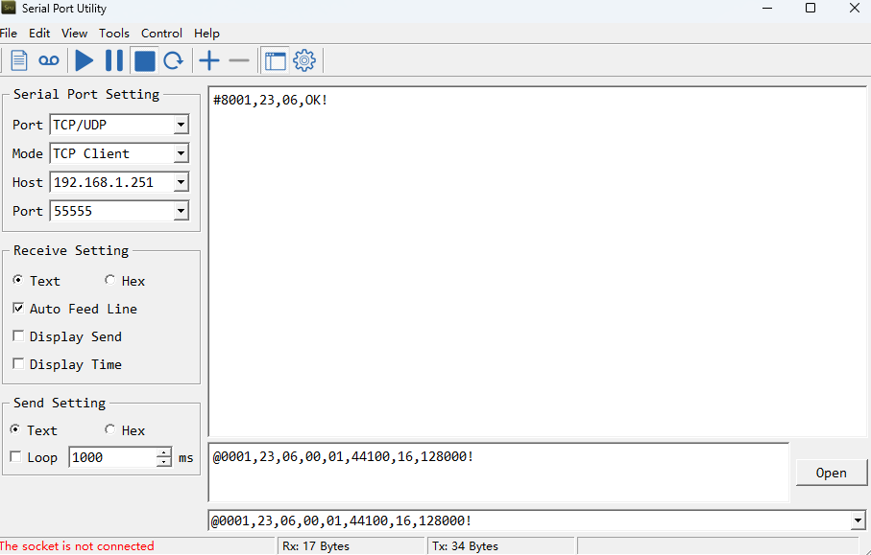

2. Set the audio format to G711u for encoding output

Command format: @0001,23,06,00,00,8000,16,0!

Note: This command is to set the encoder audio encoding format to G711u.

Command execution success: #8001,23,06,OK!

Command execution fails: #8001,23,06,ERR!

The command tool setting method chart is as follows:

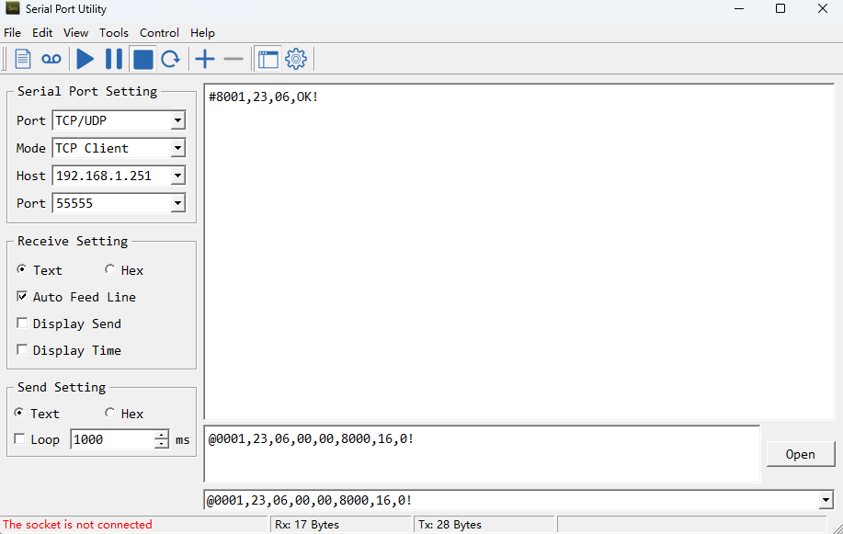

3. Set the video encoding parameters

Command format:

@0001,22,06,chn,bps,fps,res_w,res_h,type,gop,profile,rc_mode,qp1,qp2,qp3!

Note: The parameters represented by each value are as follows, please type the value within the specified range.

chn: The main stream is 0, and the sub stream is 1.

bps: video encoding bit rate, in bps. Range is [32-16384]

fps: video encoding frame rate.

res_w: The horizontal resolution of the encoded video.

res_h: The vertical resolution of the encoded video.

type: video encoding format, H.264 is 0, H.265 is 1

gop: The range is [1-600]

profile: baseline is 0, main is 1, high is 2

rc_mode: bit rate control mode, CBR is 0, VBR is 1, AVBR is 2, FixQP is 3

qp1, qp2, qp3: bit rate control parameters, related to rc_mode value.

When rc_mode = 1:

qp1: max_qp, the value range is [1, 51]

qp2: min_qp, the value range is [0, 50]

qp3:min_iqp

When rc_mode = 3:

qp1: iqp, the value range is [0, 50]

qp2: pqp, the value range is [0, 50]

qp3: bqp

Command execution success: #8001,23,06,OK!

Command execution fails: #8001,23,06,ERR!

The command tool setting method chart is as follows:

